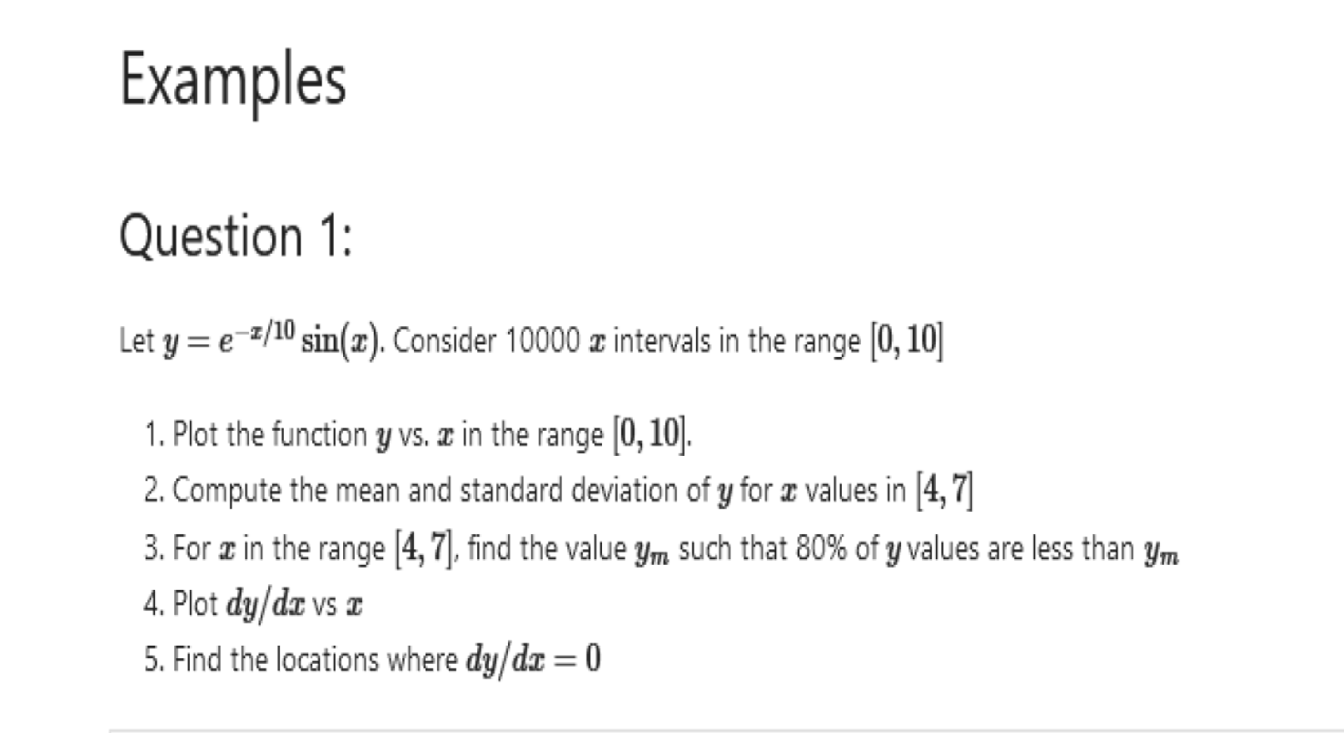  
code

……..

import numpy as np

import matplotlib.pyplot as plt

x=np.linspace(0,10,10001)

y=np.exp(-x/10)\*np.sin(x)

dydx=np.gradient(y,x)

plt.plot(x,dydx,label="derivative")

plt.plot(x,y,label="function")

plt.axhline(y = 0, color = 'g', linestyle = '-')

plt.legend()

a1=np.mean(y[(x>=4)\*(x<=7)])

a2=np.std(y[(x>=4)\*(x<=7)])

a3=np.percentile(y[(x>=4)\*(x<=7)],80)

print("mean is =",a1)

print("standard deviation is =",a2)

print(a3)

a4=x[1:][dydx[1:]\*dydx[:-1]<0] #at dydx=0 derivative change the sign

print("extremum points are",a4)

a5=x[1:][y[1:]\*y[:-1]<0] #function changes its sign.

print("roots are",a5)

……………………………………………………………